Magento / ContactLab Integration  
Quick Install Guide

Content

Preface 2

System requirements 2

PHP Compatibility 2

Required extensions 2

MySQL 2

Server - hosting - setup 2

Pre install checks 3

Environment checks 3

Installation steps 3

Auto-generated tasks 4

First export 4

Checklist 4

Queue the export 4

Checklist for a retry 5

# Preface

This is a Quick Install Guide of the Magento / ContactLab platform integration plugin.

This plugin connects Magento to the ContactLab Platform to allow the sending of newsletters to Magento subscribers through the professional ContactLab service, and it is composed by the following parts:

* a configuration section where the module can be configured
* a function to export newsletter subscribers
* a function to import newsletter unsubscriptions
* a function to send transactional email through ContactLab Smart Relay
* a function to send Magento campaigns, abandoned cart and wishlist remind through the ContactLab XML Delivery
* a queue to manage tasks

Note: this is only a brief guide to install, for more details about configuration, please, read the full documentation.

# System requirements

Magento (1.4 to 1.9)

## PHP Compatibility

5.2.13 - 5.3.24

## Required extensions

|  |  |  |  |
| --- | --- | --- | --- |
| PDO_MySQL | Simplexml | Mcrypt | Hash |
| GD | DOM | iconv | curl |
| SOAP (if Webservices API is to be used) | Safe_mode off | Memory_limit no less than 256Mb (preferably 512) |  |

## MySQL

EE 1.13.0.0 or later: MySQL 5.0.2 or newer

EE 1.12.0.2 or earlier: MySQL 4.1.20 or newer

CE (all versions): MySQL 4.1.20 or newer

## Server - hosting - setup

Ability to run scheduled jobs (crontab) with PHP 5

Ability to override options in .htaccess files

# Pre install checks

Before module installation, please make sure to have the following files:

|  |  |
| --- | --- |
| contactlab_x.y.z_step1.tgz | Plugin sources |
| contactlab_x.y.z_step2.tgz | Magento Plugin activation files |
| contactlab.xml | Contactlab customer configuration file |
| ContactlabMagento-x.y.z.docx | Detailed documentation file |
| Quick install guide | This file |

## Environment checks

* Make sure to have an Admin account to access the Magento admin panel.
* Make also sure that into your web server the cron task it has been configured properly[1].

# Installation steps

Below are described all steps to install the plugin.

|  |  |
| --- | --- |
| File | Operations |
| contactlab.xml | Copy this file into [MAGENTO_ROOT]/app/etc dir |
|  | Clear the config cache:   * from the admin panel * or remove remove all [MAGENTO_ROOT]/var/cache/mage* files if you’re not in production environment * or clear memcached cache if installed and used by Magento |
| contactlab_x.y.z_step1.tgz | *untar* this file into [MAGENTO_ROOT] path:  **ssh [YOUR_SERVER]**  **cd [MAGENTO_ROOT]**  **tar xvzf contactlab_x.y.z_step1.tgz**  (this step won’t activate the plugin. Magento is still ignoring the plugin) |
| contactlab_x.y.z_step2.tgz | *untar* this file into [MAGENTO_ROOT] path:  **ssh [YOUR_SERVER]**  **cd [MAGENTO_ROOT]**  **tar xvzf contactlab_x.y.z_step2.tgz**  Clear cache again, logout from admin and re-login |

After this steps, in Magento backend you will see:

* The menu Contactlab under Newsletter menu.
* The configuration tab “Contactlab” into configuration admin panel.

# Auto-generated tasks

After the steps described into the above paragraph, into the ContactLab Task Page (Newsletter » ContactLab » Tasks) you’ll find two auto generated tasks:

1. **Calculate statistics** – Generates statistics for customers[2]. The length of is operation depends on how many customers are stored into the Magento installation and on your machine hardware.
2. **Update UK table** – Fills the correspondence table between Magento customers and/or Newsletter subscribers and ContactLab platform entities.

If the operating system cron it’s been properly configured, both task will soon be started.

# First export

This paragraph is a short description of the first Magento/ContactLab export.

### Checklist

This is a checklist for a pre-export operation.

|  |  |
| --- | --- |
| Operation | Details |
| Check common configuration | Check the “ContactLab » Setup” configuration tab.  Check **FTP Configuration** and **SOAP configuration**. |
| Check UK table status | Open Task page and click “Check unique Keys”. If some errors have been found, queue an “UK update” task |
| Check statistics | Open Task page and click “Fill statistics”. |
| Check export configuration | Check “Magento ⇒ ContactLab Configuration”.  Is the export enabled?  Check “Export [billing/shipping] address” values.  Set Export Policy to “All subscribers only for the next export”  Check “Always export not subscribed users” value.  Set “Reset export dates before next export” to Yes. |

### Queue the export

After the checklist, you can queue the execution of the export manually by clicking “Queue Subscription export job” into the task page.

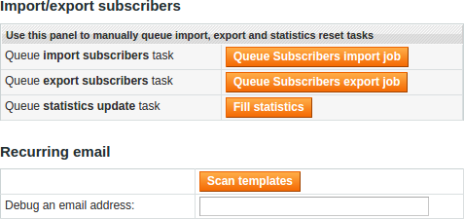

One queued, if there’s no cron configured for Magento, run manually the task. When the task is finished, check the exit status of the task clicking in the corresponding table row.

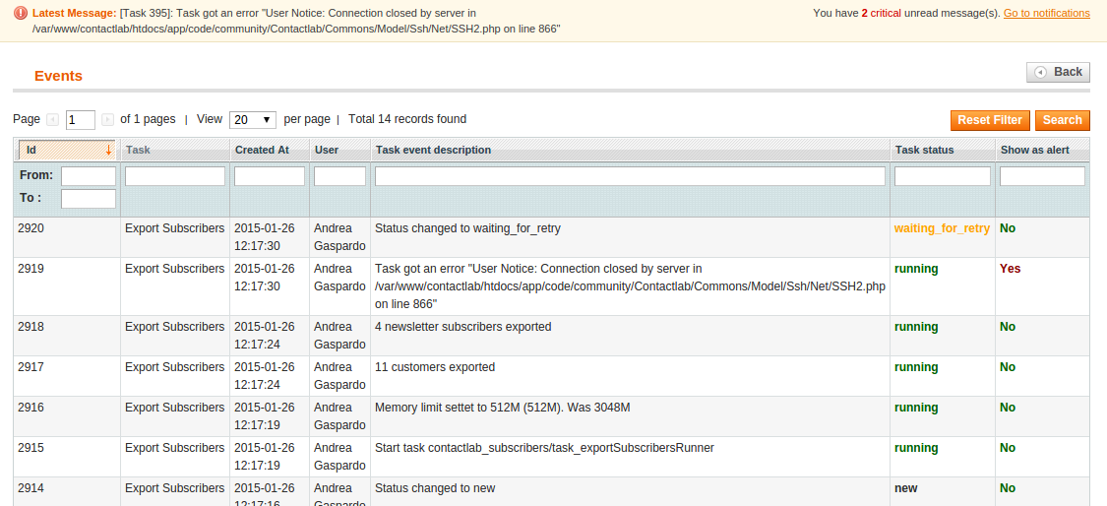

In this example, there has been an error during FTP transfer of the file.

### Checklist for a retry

If an export has failed, this is a checklist to perform another attempt, after the causes of the error has been removed.

|  |  |
| --- | --- |
| Operation | Details |
| Check export configuration | Set Export Policy to “All subscribers only for the next export”  Check “Always export not subscribed users” value.  Set “Reset export dates before next export” to Yes. |

Then, remove from the queue any other export task and queue again another export.

# Periodical cron setup

After the export and import tasks has been tested, a production environment often needs an automated execution of these tasks.

In order to configure automatic cron execution, you need to create (or edit) an xml file into [MAGENTO_ROOT]/app/etc path, called contactlab-local.xml.

**<?xml version="1.0"?>**

**<config>**

**<crontab>**

**<jobs>**

**<!-- Add the following tag to queue an export task at 9:30 pm of every day -->**

**<contactlab_subscribers_export_subscribers>**

**<schedule>**

**<cron_expr>30 21 * * *</cron_expr>**

**</schedule>**

**<run>**

**<model>contactlab_subscribers/cron::addExportSubscribersQueue</model>**

**</run>**

**</contactlab_subscribers_export_subscribers>**

**<!-- Add the following tag to queue an import task at 2:30 am of every day -->**

**<contactlab_subscribers_import_subscribers>**

**<schedule>**

**<cron_expr>30 02 * * *</cron_expr>**

**</schedule>**

**<run>**

**<model>contactlab_subscribers/cron::addImportSubscribersQueue</model>**

**</run>**

**</contactlab_subscribers_import_subscribers>**

**</jobs>**

**</crontab>**

**</config>**

An example of this file can be found into app/code/community/Contactlab/Commons/docs path.

1. More details here:  
   <http://www.magentocommerce.com/wiki/1_-_installation_and_configuration/how_to_setup_a_cron_job>
2. Statistics will be update during the site lifetime. Make sure to recalc them if you change the period of aggregation that by default is 30 and 60 days.